**Assignment – Solution**

* **Submitted by Balakrishna Gadiyar**

**Comprehension**

The pharmaceutical company Sun Pharma is manufacturing a new batch of painkiller drugs, which are due for testing. Around 80,000 new products are created and need to be tested for their time of effect (which is measured as the time taken for the drug to completely cure the pain), as well as the quality assurance (which tells you whether the drug was able to do a satisfactory job or not).

**Question 1:** The quality assurance checks on the previous batches of drugs found that — it is 4 times more likely that a drug is able to produce a satisfactory result than not.

Given a small sample of 10 drugs, you are required to find the theoretical probability that at most, 3 drugs are not able to do a satisfactory job.

 a.) Propose the type of probability distribution that would accurately portray the above scenario, and list out the three conditions that this distribution follows.

b.)  Calculate the required probability.

**Answer –**

Let us assume drug test would produce two result, satisfactory and unsatisfactory result. As there is times likely chances of test being successful over unsatisfactory, it is safe to assume, for 1 unsatisfactory tests there are 4 satisfactory tests.

P(X=Satisfactory) = 8/10= 4/5= 0.8,

P(X=Unsatisfactory)=2/10=1/5= 0.2

As the result of the test is logical, theoretical probability distribution that can be applied here is Binomial Distribution but in cumulative aspect.

There are 3 conditions to be noted here ,

1. Total number of trials is fixed at n, assuming 10
2. Each trial is binary, this is there are 2 outcomes, satisfactory and unsatisfactory in this case
3. Probability of success is same in all trials.

In this case, Population size (N) = 80000, Sample Size (n)=10, p=0.2 for unsatisfactory, r = 3

P(X=r)= nCr(p)r(1-p)n-r

P(X=3 failures)= 10C3(0.2)3(1-0.2)10-3

= 120*0.008 * 0.2097 = 0.2013

Also, if we are looking from another perspective –

P(X=7 satisfactory)= 10C7(0.8)7(1-0.8)10-7

= 120* 0.2097 *0.008 = 0.2013

Required probability only 3 drug failures is 20.13% or 0.2013

As specified earlier, If we are to consider at most 3 drug failures, identifying and summing up to 3 drug failure, we get,

P(X <=3)= P(x=0 fails)+ P(x=1 fails)+P(x=2 fails)+P(x=3 fails)

Cumulative Probability will be = 0.1074+0.2684+0.30198+0.2013= 0.8791 or 87.91%

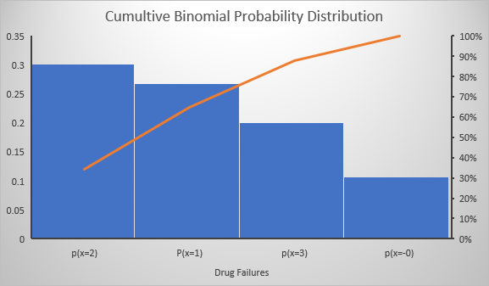

**Question 2:** For the effectiveness test, a sample of 100 drugs was taken. The mean time of effect was 207 seconds, with the standard deviation coming to 65 seconds. Using this information, you are required to estimate the range in which the population mean might lie — with a 95% confidence level.

a.)Discuss the main methodology using which you will approach this problem. State all the properties of the required method. Limit your answer to 150 words.

b.)Find the required range.

**Answer –**

Let us consider the details from the questions and arrive at some of the factors,

Population(N) – 80,000,

Sample(n)= 100,

Sample mean(u)=207 seconds,

Standard deviation = 65 seconds,

Confidence Level = 95%

Using Central limit theorem we can estimate the population mean from the sample mean and standard deviation.

This theorem defines,

* Sampling distribution mean equals population mean,
* Standard error is derived by root of sample size over population’s std.deviation
* iI sampling distribution is above 30 then normal distribution will be applicable.

Standard Error can be calculated as = Sample **Std Deviation/Root of sample size** = 65/root(100)=6.5

Here n=100, hence normal distribution is applicable.

Z score for given confidence level of 95% is +-1.96

Confidence interval = (\bar{X}-\frac{Z^{*}S}{\sqrt{n}}, \bar{X}+\frac{Z^{*}S}{\sqrt{n}})

Std mean and population mean differ by Margin of Error =\frac{Z^{*}S}{\sqrt{n}}. = 1.96*6.5=12.74

**Required interval is (207-12.74, 207+12.74) = (194.26 seconds ,219.74 seconds)**

**Question 3**:

a) The painkiller drug needs to have a time of effect of at most 200 seconds to be considered as having done a satisfactory job. Given the same sample data (size, mean, and standard deviation) of the previous question, test the claim that the newer batch produces a satisfactory result and passes the quality assurance test. Utilize 2 hypothesis testing methods to make your decision. Take the significance level at 5 %. Clearly specify the hypotheses, the calculated test statistics, and the final decision that should be made for each method.

 b) You know that two types of errors can occur during hypothesis testing — namely Type-I and Type-II errors — whose probabilities are denoted by α and β respectively. For the current hypothesis test conditions (sample size, mean, and standard deviation), the value of α and β come out to 0.05 and 0.45 respectively.  
 Now, a different sampling procedure is proposed so that when the same hypothesis test is conducted, the values of α and β are controlled at 0.15 each. Explain under what conditions would either method be more preferred than the other.

**Answer –**

Population(N) = 80,000

Sample Size(n) = 100

Sample Mean – 207 seconds

Standard Deviation – 65

Significance Level – alpha = 5%

Mean = 200

Standard Error can be calculated as = Sample **Std Deviation/Root of sample size** = 65/root(100)=6.5

**H0= Null Hypothesis <=200 seconds produces satisfactory results**

**H1= Alternative Hypothesis > 200**

To identify critical value, as it is upper tailed scenario, we see the 0.05 is the significance level, hence it leaves us with the region value 0.950

Corresponding Zc = 1.645 ( 0.950 is not there, taking the closest for 0.9495 is 1.64, 0.9505 is 1.65, taking average)

Critical Value can be derived using,

u+(Zc*std.dev sample) = 200+(1.645*6.5) = 200+-10.69

Upper Critical Value = 200+10.69 = 210.69

**Conclusion on basis of first method -** **Sample mean lies in the acceptance region of the curve, hence we fail to reject the null hypothesis.**

Now, Let us calculate the p-value for this scenario,

Z-score = (X’-mean)/ std error = (207-200)/6.5=1.0769=1.08.

Hence Z value turns out to 0.8599

As it is one tailed (upper tailed), p-value come = 1-0.8599 = 0.1401

**Conclusion on basis of second method - We come to conclusion that p value is way higher than significance level, i.e. 0.05< 0.1401, hence we fail to reject the null hypothesis.**

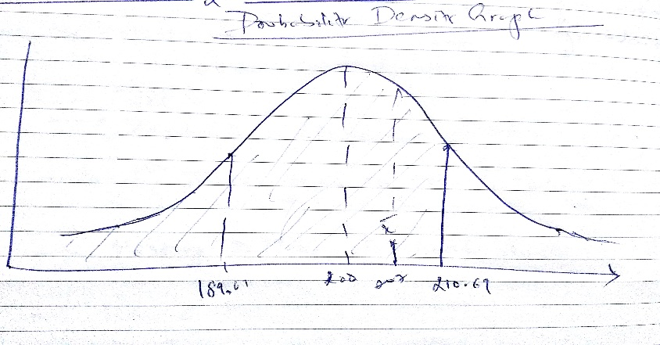

Part 2 of the question,

In the first scenario, alpha is 0.05 and Beta is 0.45, is the condition where we see Type 2 error frequently.

On the latter, both values are at same value, hence chances of type 1 error increases compared to the former.

As Type 1 error is less dangerous than type 2, latter with both values at 0.15 preferred.

**Question 4**: Now, once the batch has passed all the quality tests and is ready to be launched in the market, the marketing team needs to plan an effective online ad campaign for its existing subscribers. Two taglines were proposed for the campaign, and the team is currently divided on which option to use. Explain why and how A/B testing can be used to decide which option is more effective. Give a stepwise procedure for the test that needs to be conducted.

A/B testing is also called as Bucket testing. It is also two sample proportion tests, highly used by marketing and advertising teams. Mostly helps in deciding a channel or method that is more efficient compared to each other. Highly used when developing online portal features on ecommerce platforms.

This testing involves with following sub tasks,

* Collecting data that is required for analysis.
* Identify the objective of testing.
* Define and arrive at hypothesis parameters
* Create variations compared to the controlling entity
* Run the tests
* Analyse the result and derive metrics
* Generate the outcome
* Run again as long as it is needed to arrive at an outcome.

If we consider the above example, Let us assume and proceed with below steps to conduct a/b testing,

1. Out of 80,000 drugs, sample of 100 were taken, necessary statistical metrics were derived
2. Objective was to observe if pain killer drug is effective enough post released to market
3. Based on sample sets, we defined the null and alternative hypothesis testing, using critical value and p value methods conclude drug is safe to release
4. With Product being approved for launch, Marketing team defines two tag lines for its sale,

P1 - Control Tagline 1 – Kill My Pain (Assuming one which was already running in the market)

P2- Variation Tagline 2 – Heal My Pain (Assume to be a new name proposed)

1. Two variations will be marketed across testing group or full production line as needed or approved by firm (set of people or entire customer fraternity).
2. Based on the sales of drugs under P1 and P2 categories, the firm captures the conversions of respective areas as P1’, P2’ respectively
3. Two Proportion tests will be conducted based on two sets,
4. The firm tries finds the difference of latter with former, i.e. P2Sales – P1Sales with a significance level defined (ideally 5%). Here hypothesis would be H0 = Old tagline is good, H1= New tagline is better than old tag line
5. Arrive at a conclusion and plan for revise the marketing strategy.
6. Extend the experiment if it is needed further to arrive at outcomes.